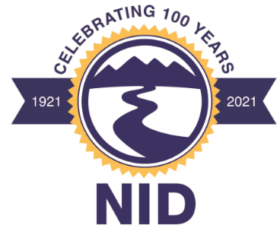

1036 West Main Street, Grass Valley, CA 95945
Telephone: (530) 273-6185 / Facsimile: (530) 271-6838
Web Site: www.nidwater.com

Chris Bierwagen, President – Division II
Karen Hull, Vice President – Division III
Ricki Heck – Division I
Laura L. Peters – Division IV
Rich Johansen – Division V

NOTICE OF MEETING CANCELLATION

* * *

Notice is hereby given that the Nevada Irrigation District Board of Directors has cancelled the regular Board meeting scheduled for Wednesday, December 22, 2021, at 9:00 a.m.

The next regular Board meeting is currently scheduled for Wednesday, January 12, 2022, at 9:00 a.m.

